## 1. NULL values

Our next lesson will review how to filter data that includes NULL values.

## 2. Missing values

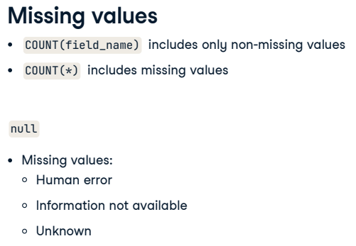

When we were learning how to use the COUNT keyword, we learned that we could include or exclude non-missing values depending on whether or not we use the asterisk in our query. But what is a missing or non-missing value? In SQL, NULL represents a missing or unknown value. Why is this useful? In the real world, our databases will likely have empty fields either because of human error or because the information is not available or is unknown. Knowing how to handle these fields is essential as they can affect any analyses we do.

## 3. null

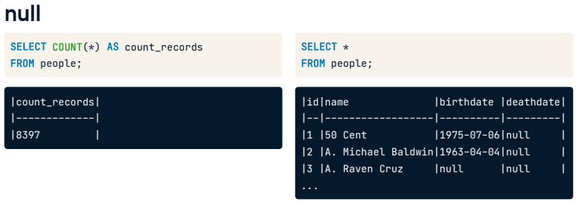

For example, we used COUNT all with an asterisk on the left. Suppose our goal is to analyze posthumous success using data from the people table. We might make the wrong assumption that because we have a field name called deathdate, this information is available for everyone. Half of them are, in fact, NULL, as we can see on the right, so we would make an inaccurate judgment on what the data means.

## 4. IS NULL

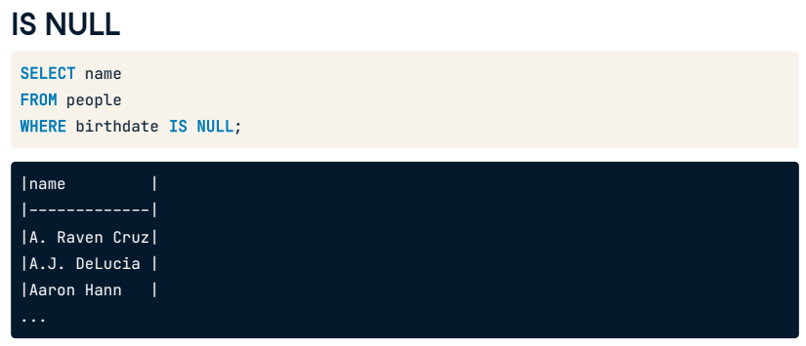

One quick way to see how much of our data is missing is by using IS NULL with the WHERE clause. Here is an example where we have checked to see which names do not have a recorded birthdate in our table.

## 5. IS NOT NULL

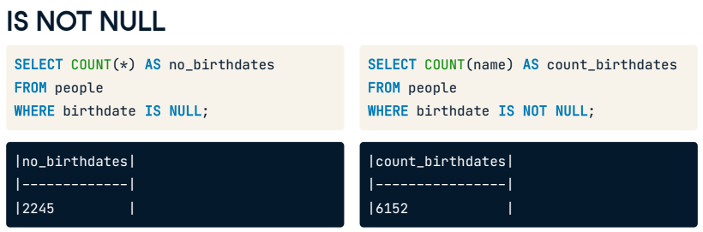

On the left is an example of counting the missing birthdates in the people table. The count is 2245. Sometimes, we'll want to filter out missing values, so we only get results that are not NULL. To do this, we can use the IS NOT NULL operator. For example, this query on the right gives the count of all people whose birth dates are not missing in the people table, giving us a new count of 6152.

## 6. COUNT() vs IS NOT NULL

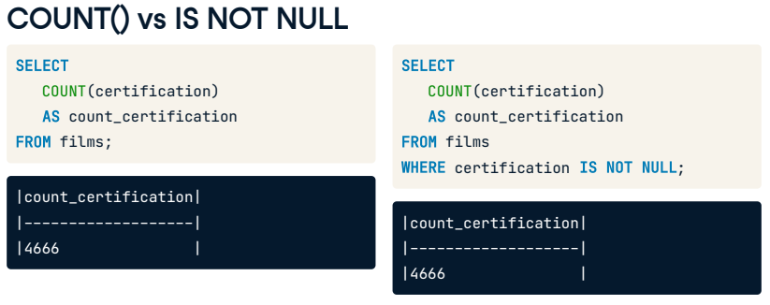

There may be a question about the difference between using COUNT with a field name and using the same COUNT with the added WHERE clause with IS NOT NULL. The answer is there is no difference, as both will be counting non-missing values.

## 7. NULL put simply

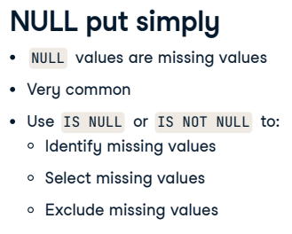

Before we wrap up this lesson, let's review what we've learned. NULL values are missing values, and they are very common in the real world. It is good practice to know how many NULL values are in our data by using the IS NULL or IS NOT NULL operator for filtering. These keywords will help to identify, select, or exclude missing values. Don't worry; this will soon become second nature because it is that common!

## 8. Let's practice!

That's a wrap! It's time for more practice.

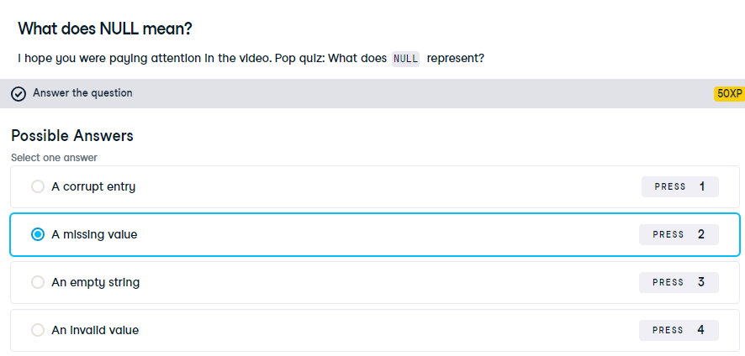

Correct! NULL is used to represent unknown values.

## Exercise

# Practice with NULLs

Well done. Now that you know what NULL means and what it's used for, it's time for some more practice!

Let's explore the films table again to better understand what data you have.

* + Select the title of every film that doesn't have a budget associated with it and use the alias no_budget_info.
  + Count the number of films with a language associated with them and use the alias count_language_known.



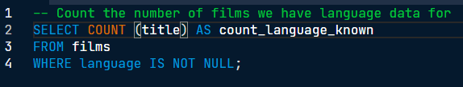

Alright! That's 4957 films with language data. We've mastered selecting and filtering data which means you're halfway through the course!